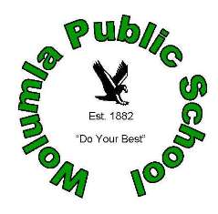

WOLUMLA PUBLIC SCHOOL
2018 Permission Notes

GENERAL CONSENT FORM

SURNAME: __________________

CHRISTIAN NAMES: __________________ ______________________

__________________ ______________________

I hereby give consent for my above-mentioned child / children to attend supervised school activities and sport visits, within the Wolumla township, which are approved by the Principal. These activities may involve travel by bus, or walking to the Wolumla Recreation Ground, the Wolumla Memorial Hall, or a walk around town within the class group.
In the event of an emergency, I give consent to the securing of medical attention, or an ambulance.

THIS CONSENT IS INTENDED TO COVER ALL SUCH OCCASIONS DURING THE YEAR

Name: ______________________________ Date: _____________
(Parent/Guardian)

Signature: ______________________________
(Parent/Guardian)

